P250/2

GEOGRAPHY

(World problems and Development)

Paper 2

3 hours

**Uganda Advanced Certificate of Education**

RESOURCEFUL MOCK EXAMS

GEOGRAPHY

(WORLD PROBLEMS AND DEVELOPMENT)

**Paper 2**

3 hours

**INSTRUCTIONS TO CANDIDATES**

Answer **FOUR** questions in all

Section **A** is compulsory

Answer **three** questions from section **B**

Any additional question(s) answered will **not** be marked

Credit is given for use of relevant sketch maps, diagrams and specific examples.

SECTION A

1. The table below shows the population of Canada in 2014 in percentages. Use it to answer questions that follow.

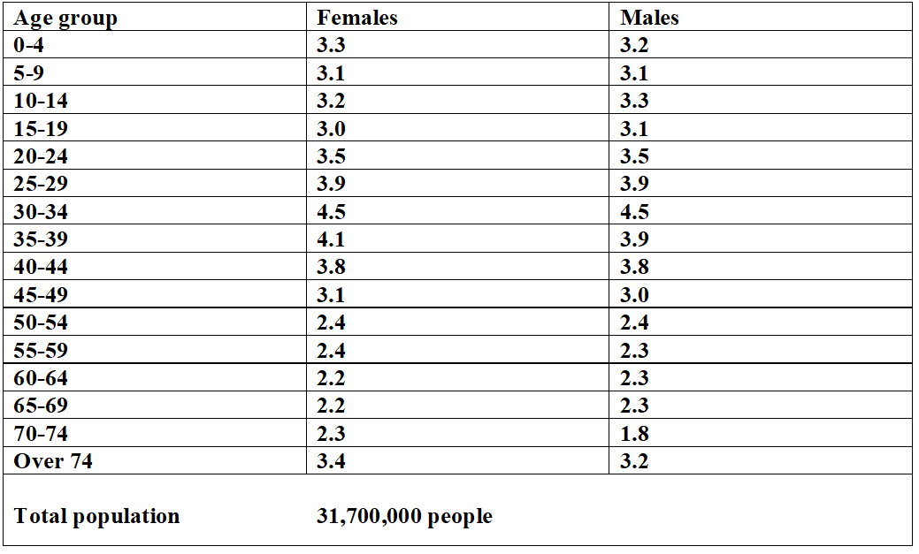

1. Draw a population pyramid to represent the information in the table above (08 marks)
2. Outline the advantages of using the method above (04 marks)
3. Describe the characteristics of Canada’s population as shown in the table above

(03 marks)

1. Calculate the total population aged;
2. 0-4 years
3. 35-39 years
4. Over 74 years (06 marks)
5. Explain the advantages of having a low population in either Norway or Namibia

(04 marks)

SECTION B

2.a) Describe the characteristics of tropical rainforests (10 marks)

1. To what extent have the physical factors limited the effective exploitation and utilisation of tropical rainforests in either DRC or Gabon? (15 marks)
2. Explain the factors hindering industrial establishments in either South Africa or Germany

(25 marks)

4. Account for the large-scale extraction of mineral resources in either Germany or south Africa (25 marks)

5. Discuss the importance of the fishing industry to the economic development of either Japan or Peru (25 marks)

6. Account for the growth and development of urban centres in tropical Africa (25 marks)

7. ‘Tourism in either Egypt or Tanzania has developed due the human factors. Assess the validity of the above statement (25 marks)

8. Explain the causes and the effects of desertification in Africa (25 marks)

**END**